LAB EXAM
SUBMITTED BY: AROOBA REHMAN(BSE-012)
SUBMITTED TO: ENGR.MUHAMMAD SHOAIB

Q1 – AWS IAM Setup Using AWS CLI and Console Verification (10 marks)

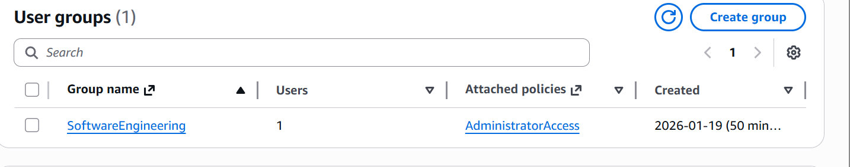

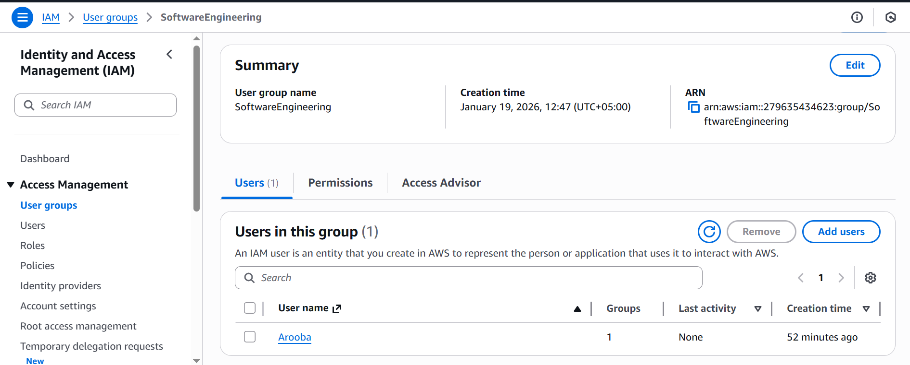

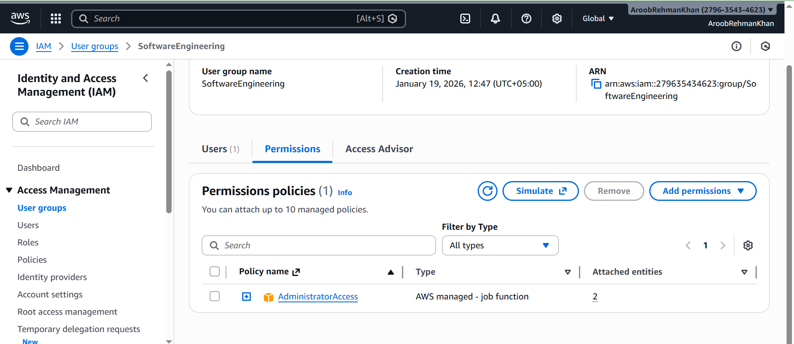

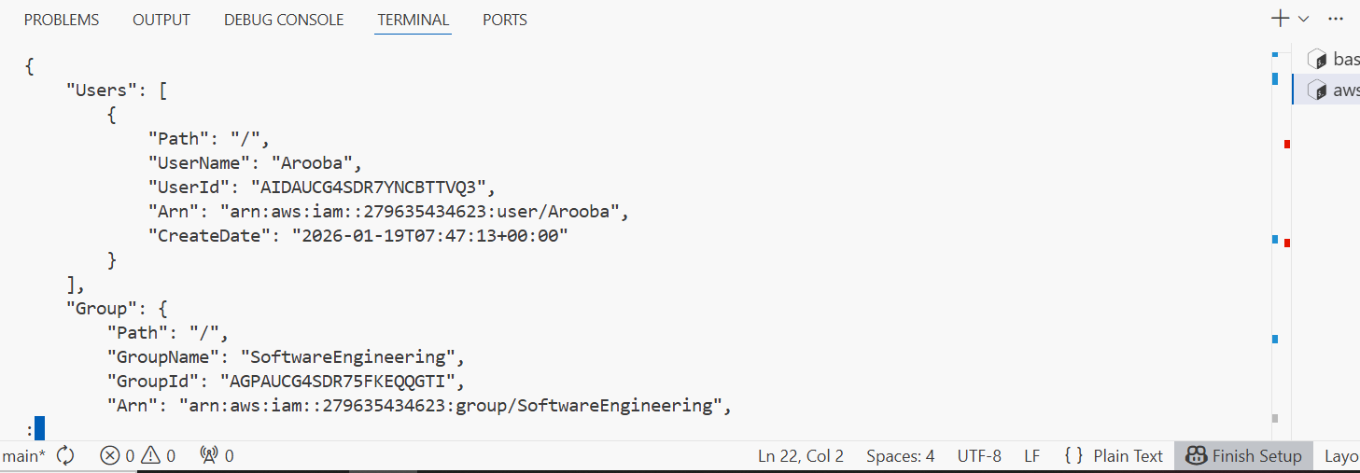

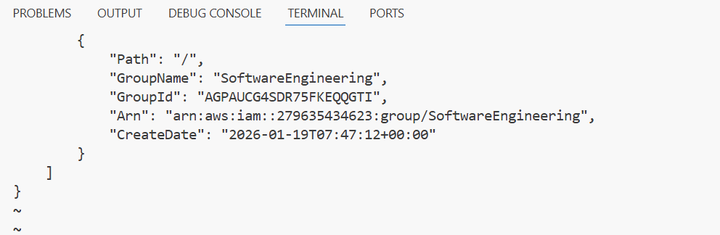

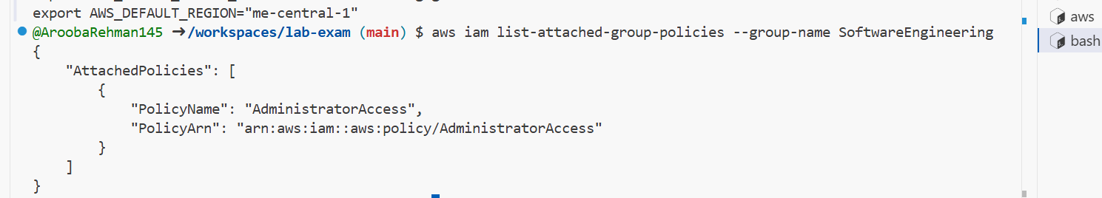

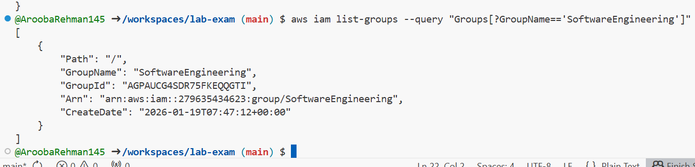

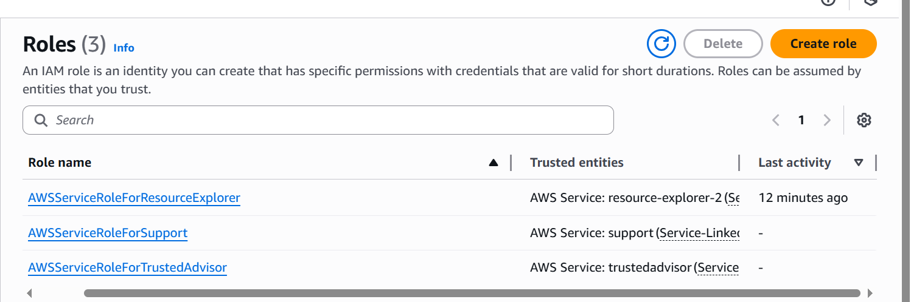

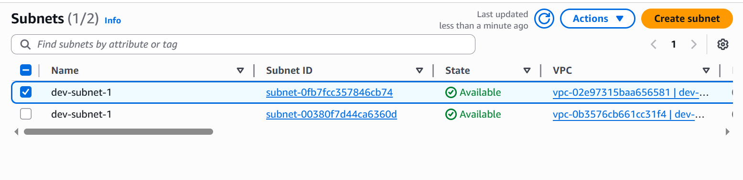

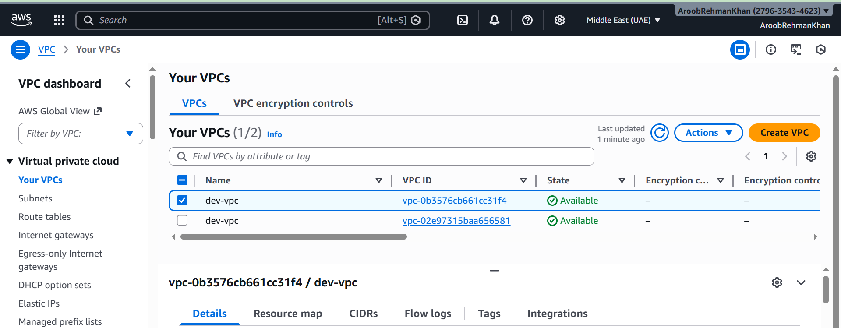

Q2 – Terraform Lab: Simple AWS Environment with Nginx over HTTPS (30 marks)
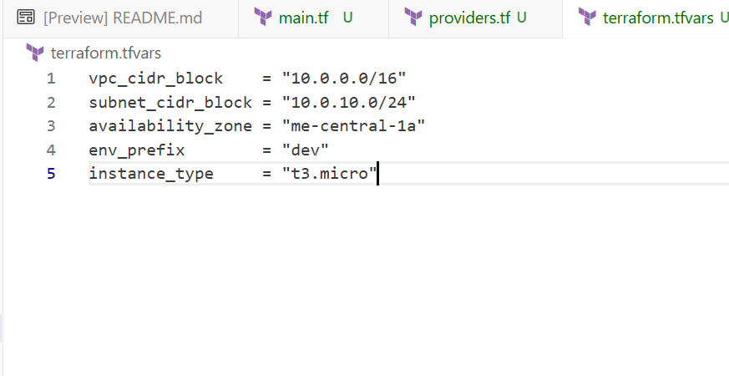

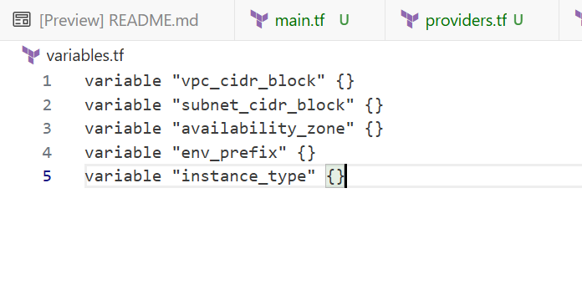

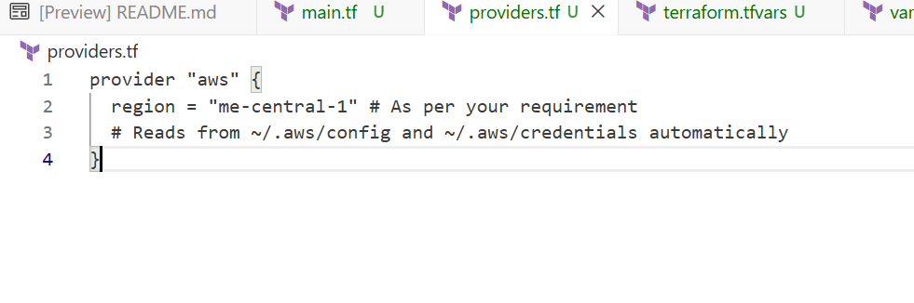
Providers was giving error so I removed it later

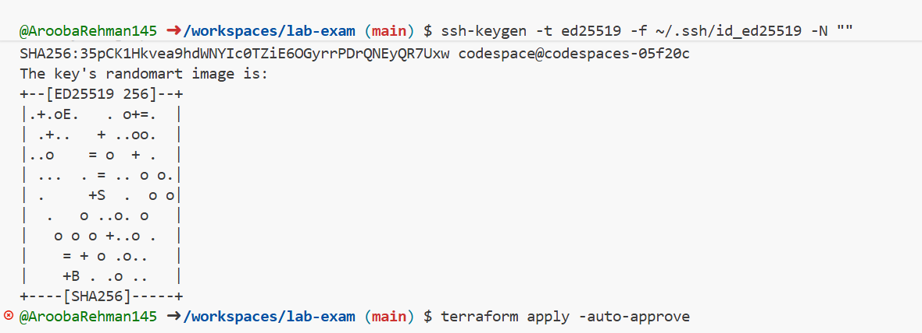

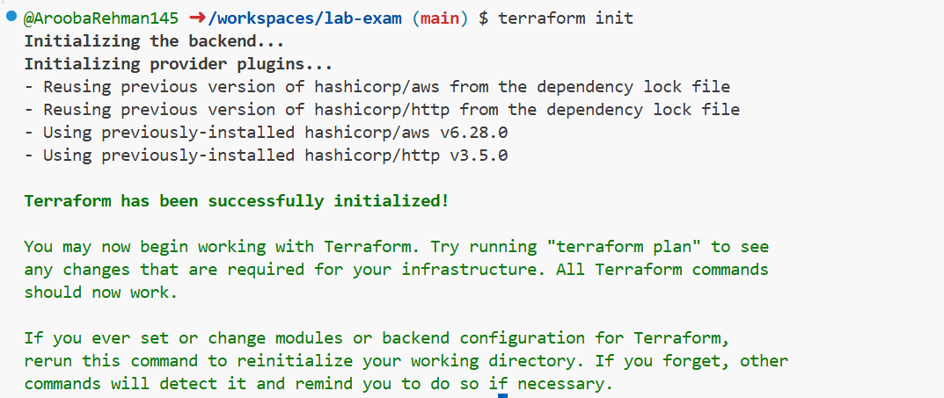

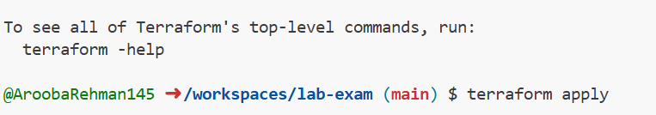
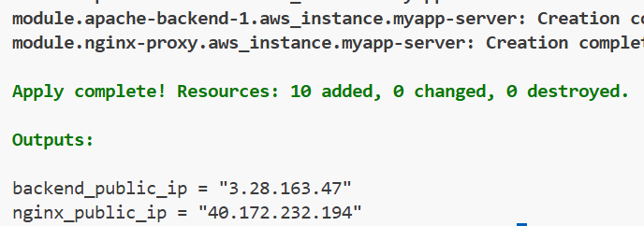

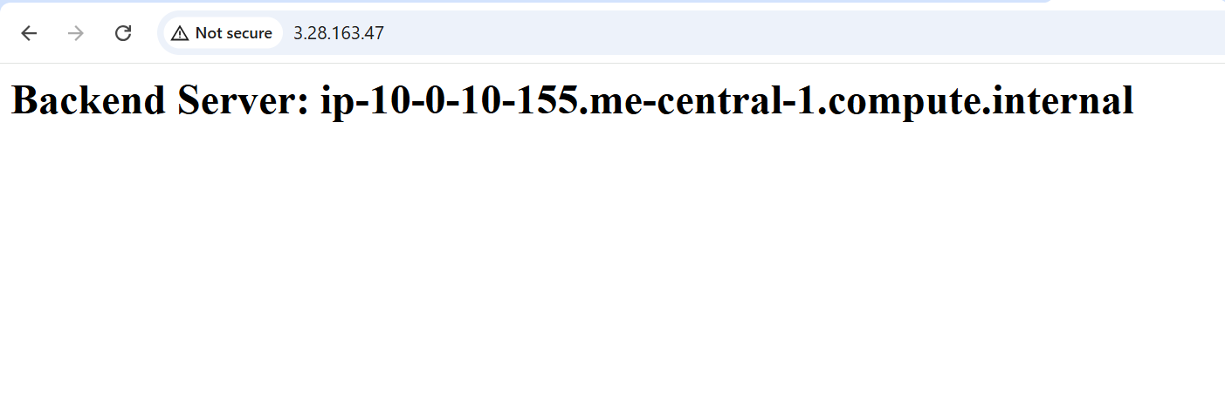

Sir mentioned to edit as MY webser Arooba:
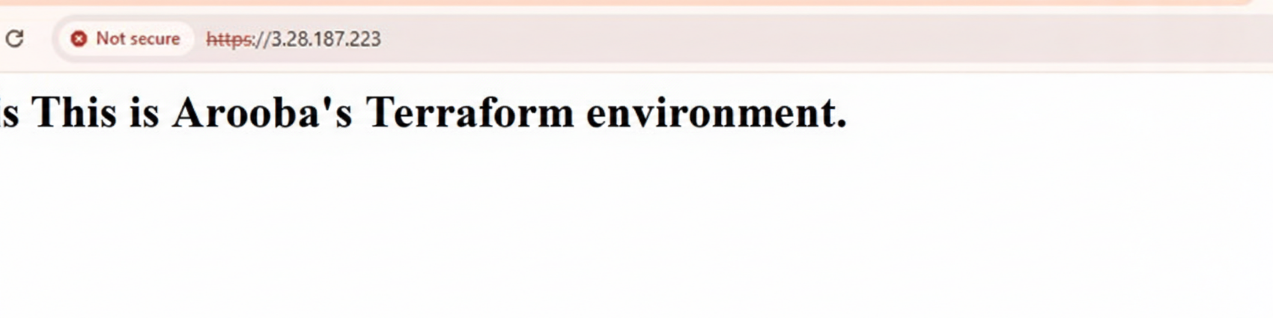

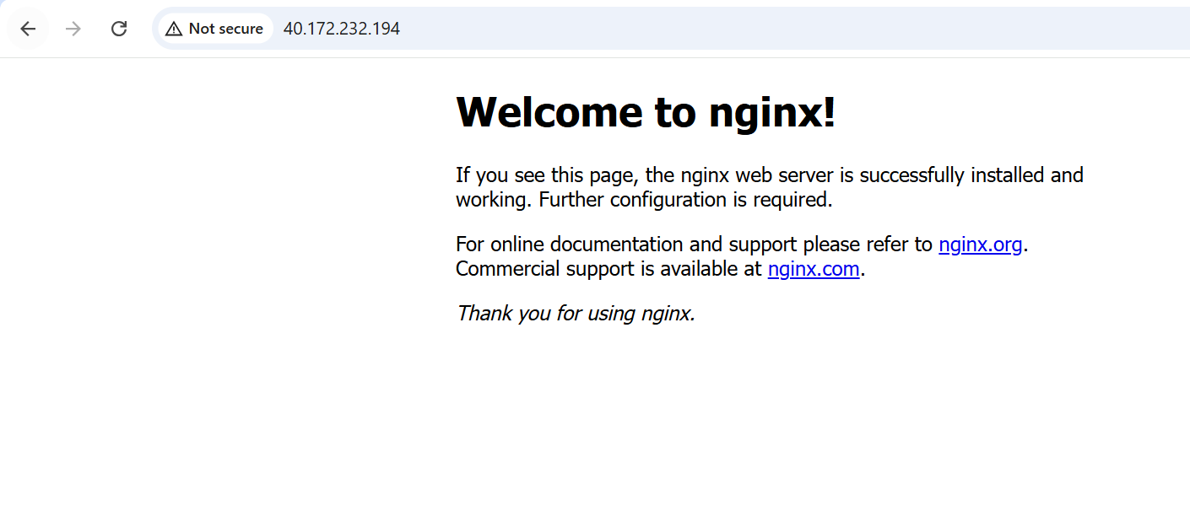

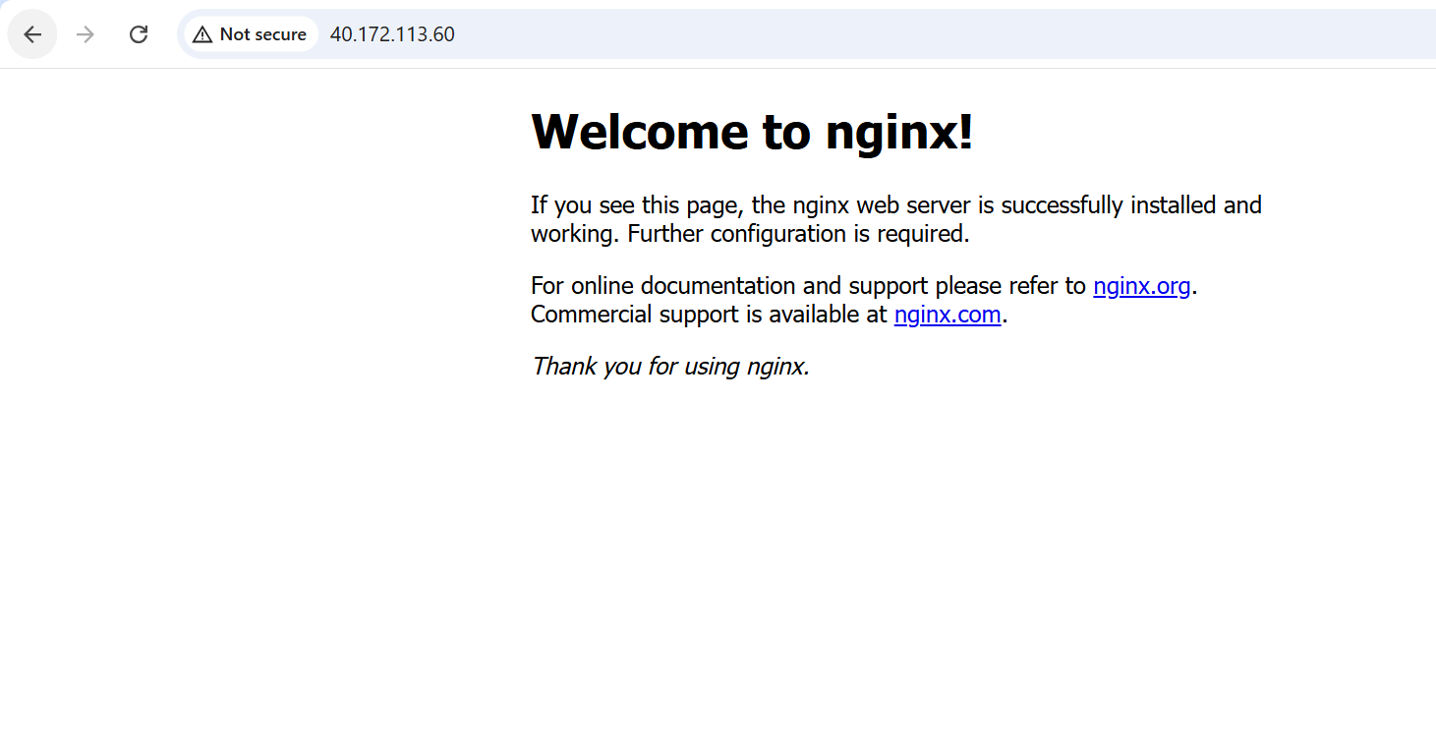

Q3 – Ansible Playbook for EC2 Web Server Using Q2 Instance (10 marks)

Ansible.cfg:

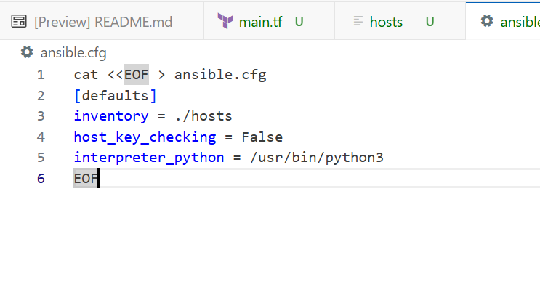
My-playbook.yml file:

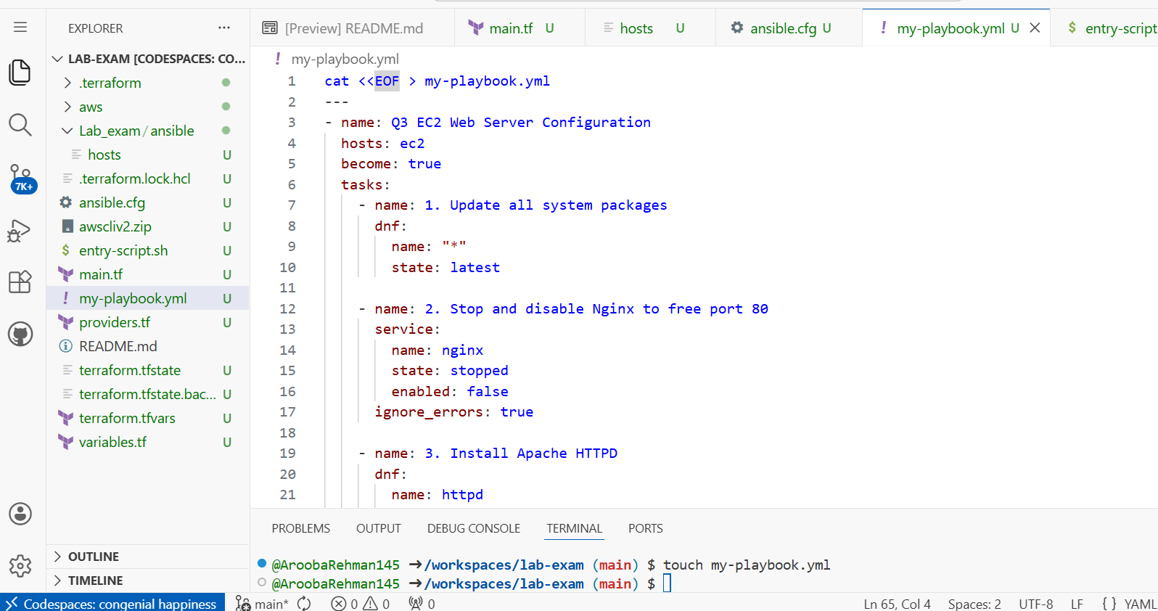

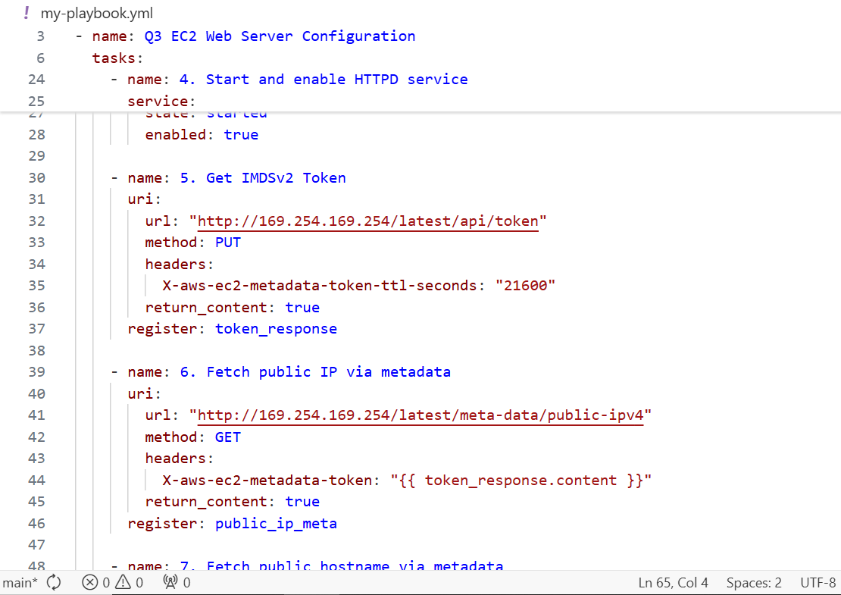

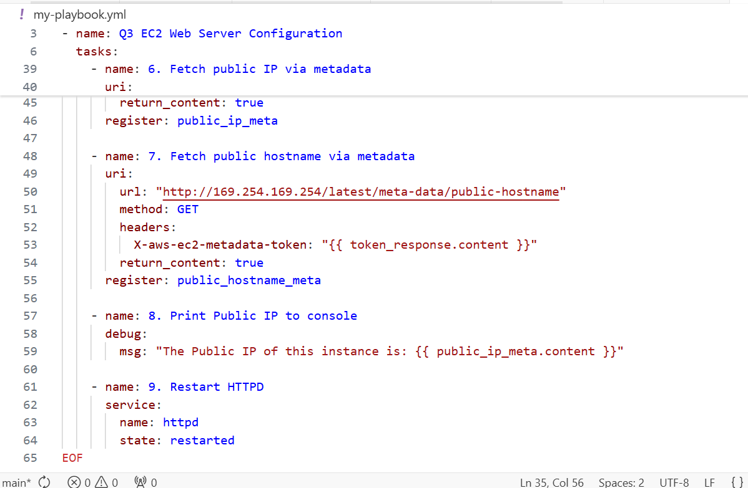



Hosts file:
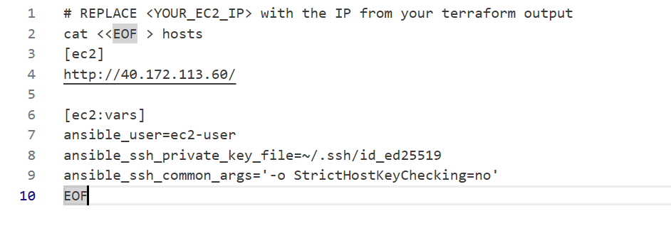
After Q2 my codespace got stuck created new one with terraformmachine:
That’s why my ips got changed:



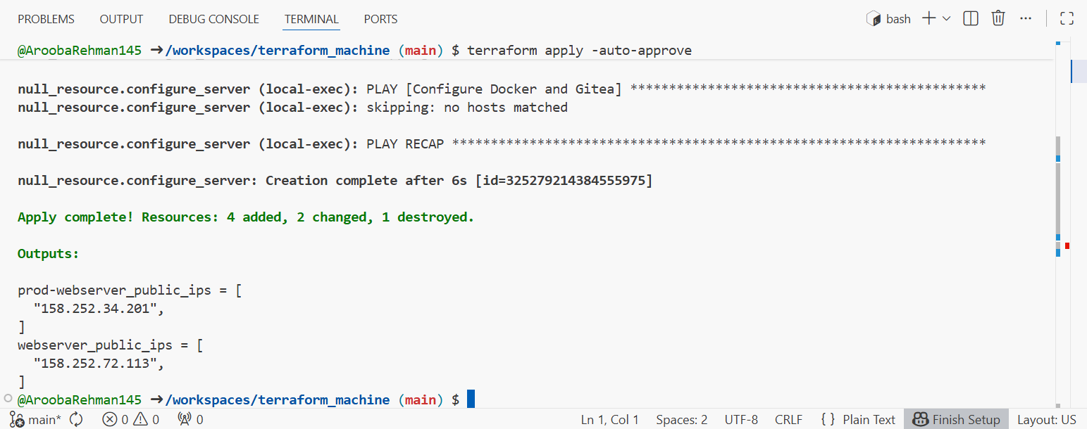

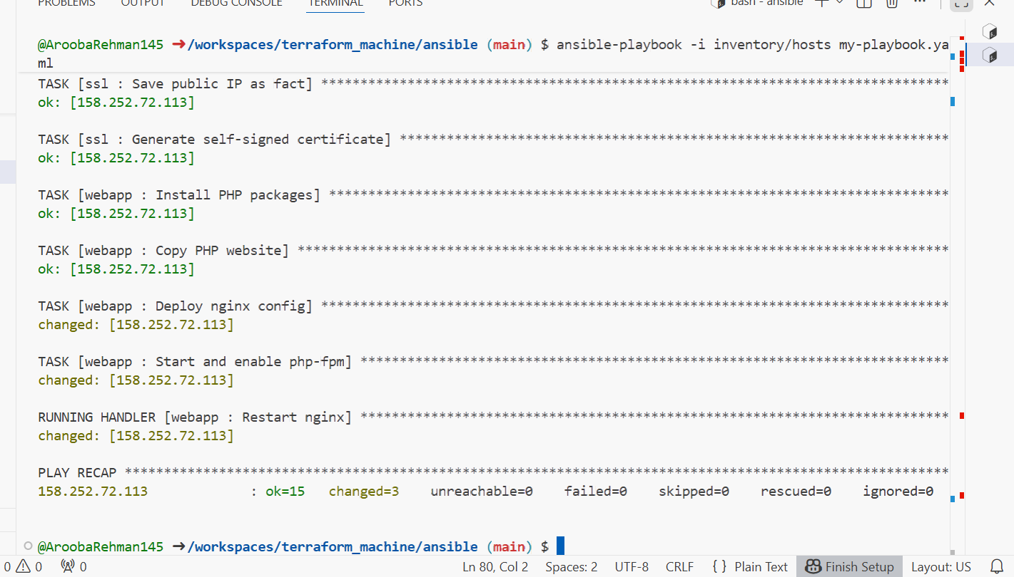
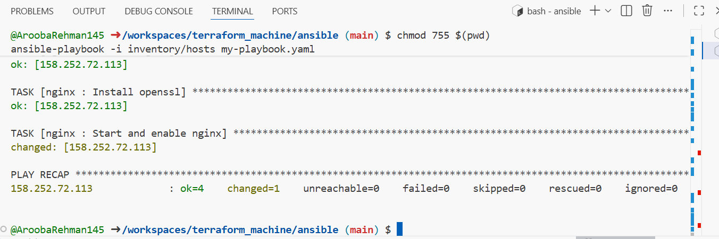

I ran destroy first then apply so my IP has been changed SIR after Q2
Full main.tf code for both tasks:

data "http" "my_ip" {
url = "https://icanhazip.com"
}

locals {
my_ip = "${chomp(data.http.my_ip.response_body)}/32"
}

provider "aws" {
region = "me-central-1"
}

# --- 3. VPC & NETWORK ---
resource "aws_vpc" "myapp_vpc" {
cidr_block = var.vpc_cidr_block
tags = { Name = "${var.env_prefix}-vpc" }
}

resource "aws_subnet" "myapp_subnet" {
vpc_id = aws_vpc.myapp_vpc.id
cidr_block = var.subnet_cidr_block
availability_zone = var.availability_zone
tags = { Name = "${var.env_prefix}-subnet-1" }
}

resource "aws_internet_gateway" "myapp_igw" {
vpc_id = aws_vpc.myapp_vpc.id
tags = { Name = "${var.env_prefix}-igw" }
}

resource "aws_default_route_table" "main_rt" {
default_route_table_id = aws_vpc.myapp_vpc.default_route_table_id
route {
cidr_block = "0.0.0.0/0"
gateway_id = aws_internet_gateway.myapp_igw.id
}
tags = { Name = "${var.env_prefix}-rt" }
}

resource "aws_default_security_group" "default_sg" {
vpc_id = aws_vpc.myapp_vpc.id

ingress {
from_port = 22
to_port = 22
protocol = "tcp"
cidr_blocks = [locals.my_ip]
}

ingress {
from_port = 80
to_port = 80
protocol = "tcp"
cidr_blocks = ["0.0.0.0/0"]
}

ingress {
from_port = 443
to_port = 443
protocol = "tcp"
cidr_blocks = ["0.0.0.0/0"]
}

egress {
from_port = 0
to_port = 0
protocol = "-1"
cidr_blocks = ["0.0.0.0/0"]
}

tags = { Name = "${var.env_prefix}-default-sg" }
}

# --- 5. KEY PAIR ---
resource "aws_key_pair" "serverkey" {
key_name = "serverkey"
public_key = file("~/.ssh/id_ed25519.pub")
}

resource "aws_instance" "myapp_server" {
ami = "ami-0eb260c4d547f872f"
instance_type = var.instance_type
subnet_id = aws_subnet.myapp_subnet.id
vpc_security_group_ids = [aws_default_security_group.default_sg.id]
availability_zone = var.availability_zone
associate_public_ip_address = true
key_name = aws_key_pair.serverkey.key_name

user_data = file("entry-script.sh")

tags = { Name = "${var.env_prefix}-ec2-instance" }
}

output "ec2_public_ip" {
value = aws_instance.myapp_server.public_ip
}
For sensitive files:
